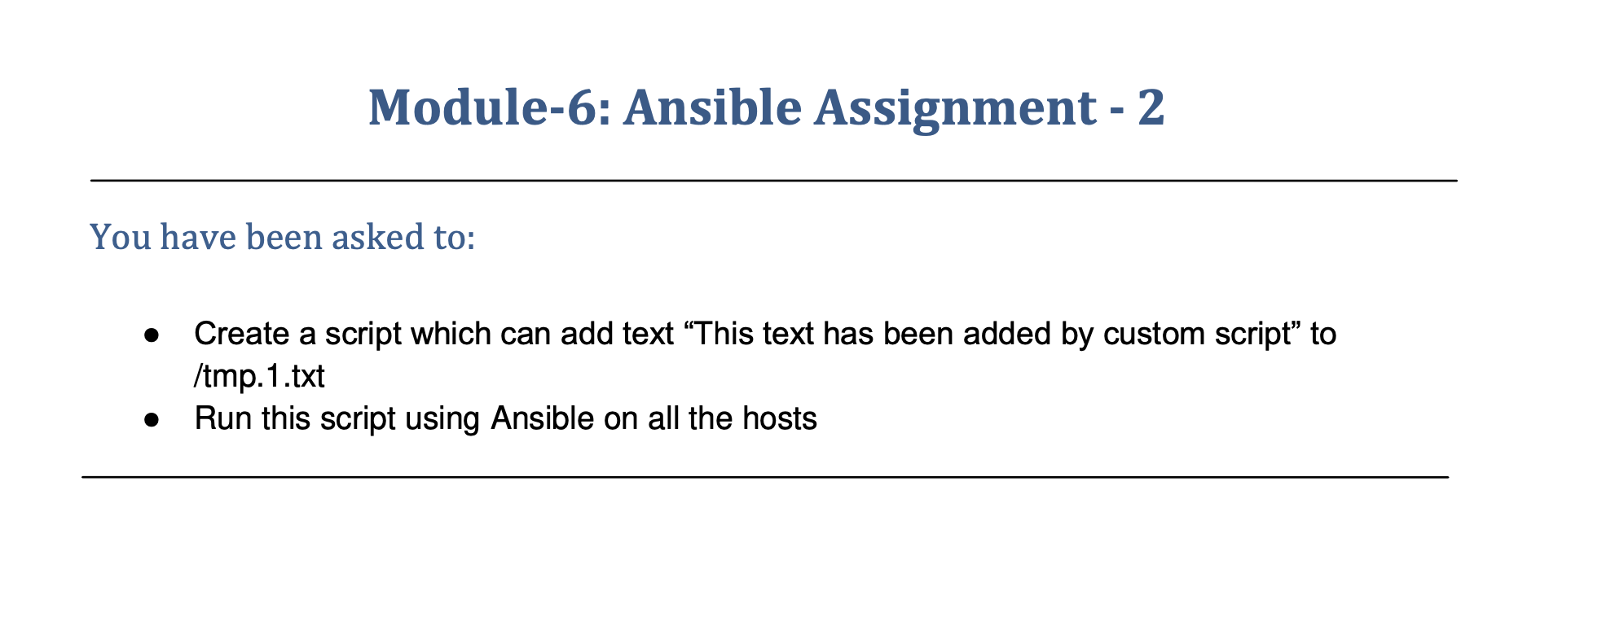

You have been asked to:

* ●  Create a script which can add text “This text has been added by custom script” to /tmp.1.txt
* ●  Run this script using Ansible on all the hosts

Login to master node

Create the two files

ubuntu@ip-172-31-37-222:/etc/ansible$ sudo nano assignment2.yaml

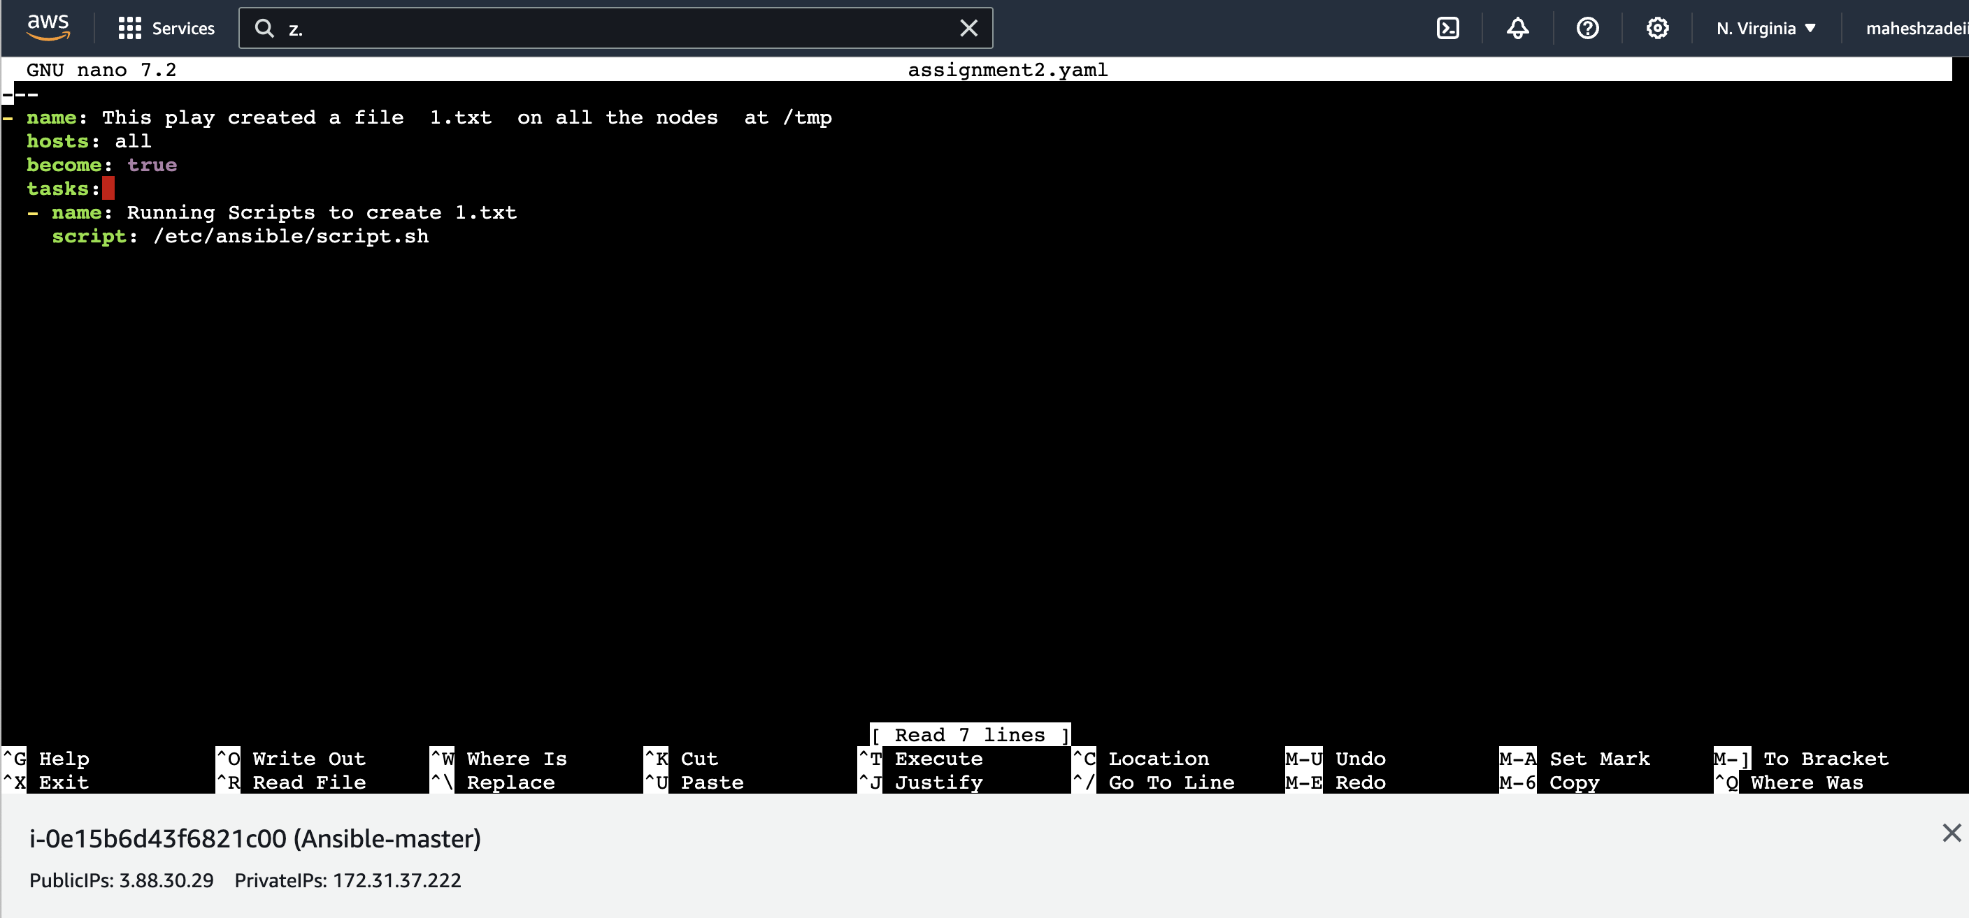

ubuntu@ip-172-31-37-222:/etc/ansible$ sudo nano script.sh

this is a custom script

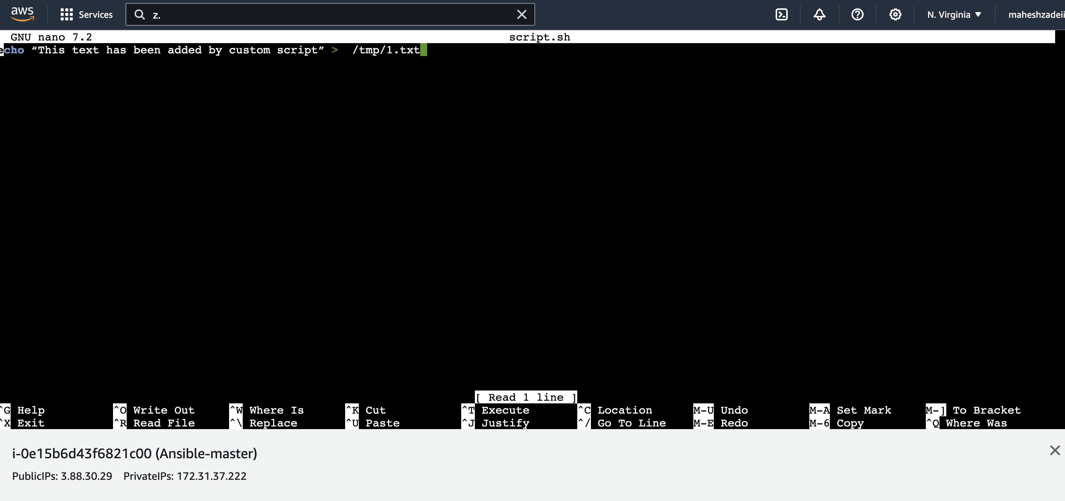

Cttrl S and Ctrl X

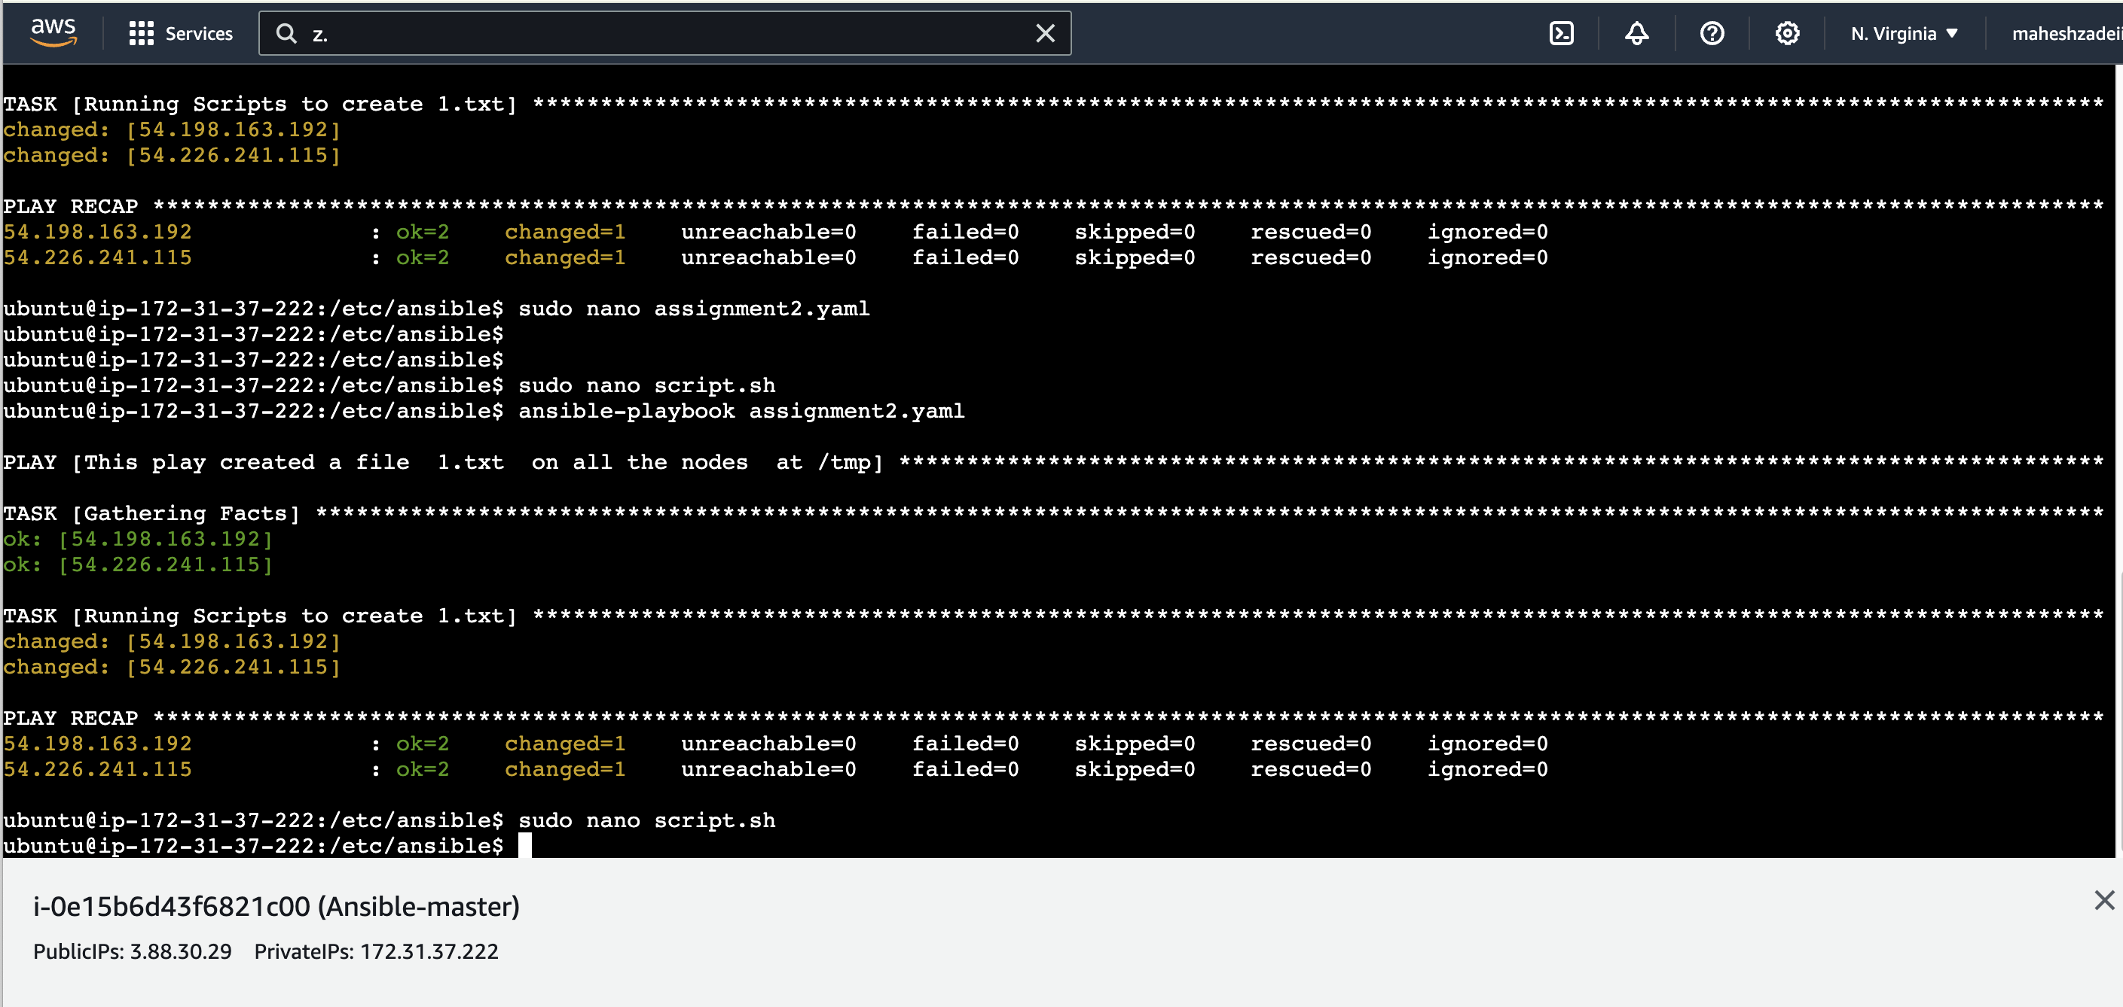

Now check the 1.txt file created or not in Slave1 and Slave2 EC2

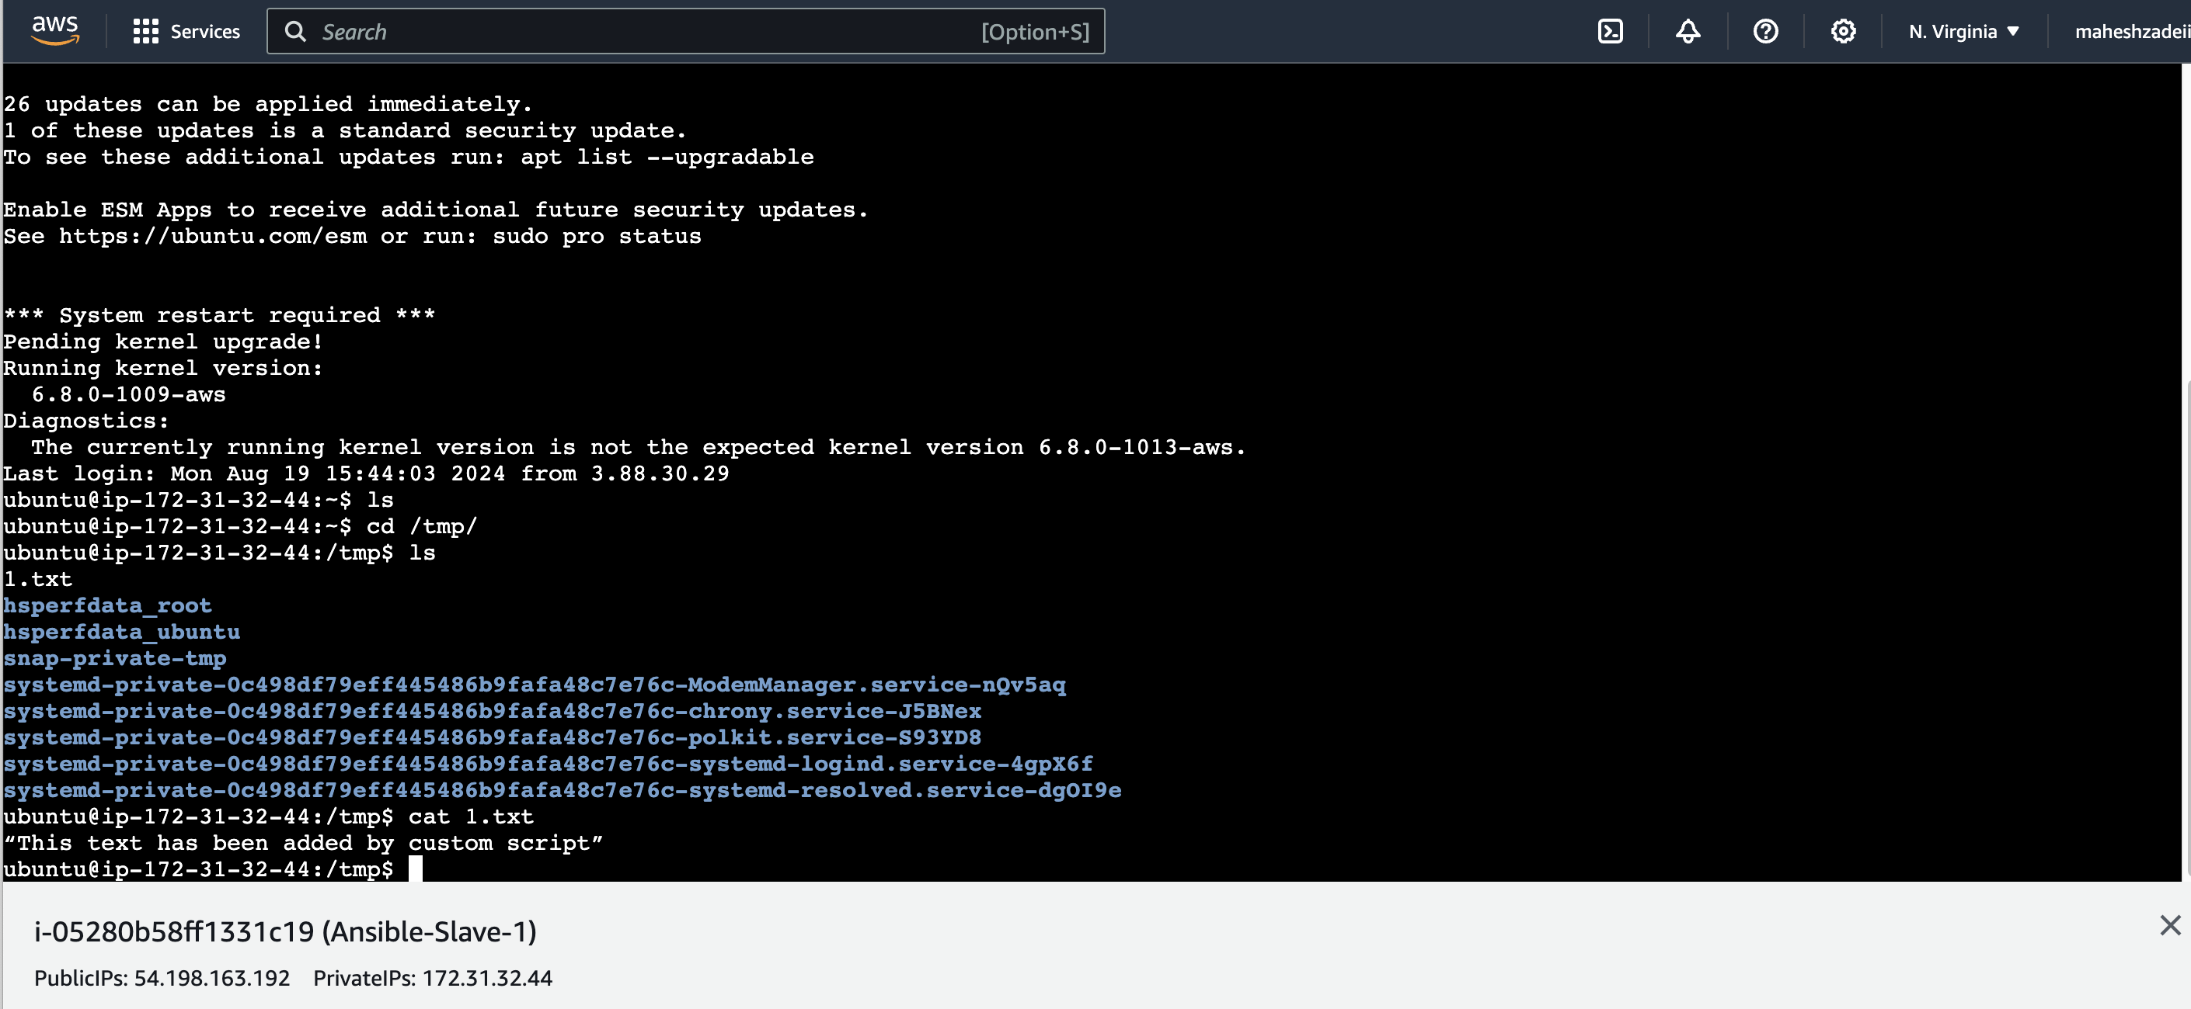

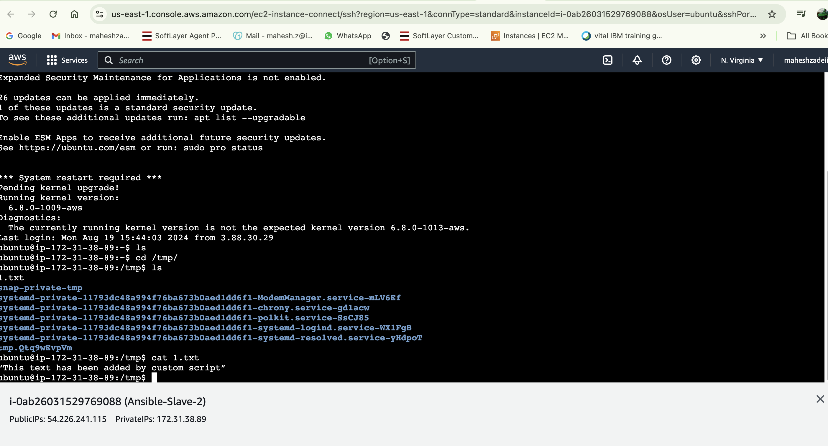

Assignment 2 for Ansible is completed successfully.